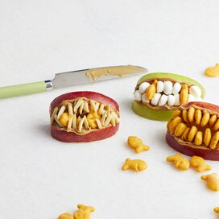

**Zombie Lips**

**Ingredients:**

1 medium apple

½ cup peanut butter

½ cup miniature fish-shaped crackers (such as Goldfish), or as needed.

**Directions:**

1. Core apple and cut into 8 slices. Spread 1 tablespoon peanut butter on 1 side of the apple slice. Press fish crackers tail-first into peanut butter to form teeth. Repeat with another apple slice and gently put on top of first slice to form a mouth. Repeat with remaining apple slices.

**Nutrition Facts (Per Serving)**

Calories 338 Prep: 30 minutes

Protein 11 g (22% DV) Additional: 5 minutes

Carbohydrates 28.8 g (9% DV) Total: 35 minutes

Fat 21 g (32% DV) Servings: 18

Cholesterol 0 mg Yields: 18 penguins

Sodium 363 mg (15% DV)